Town of Newington
Conservation Commission
205 Nimble Hill Road
Thursday, June 11, 2026
At
6:00
A G E N D A

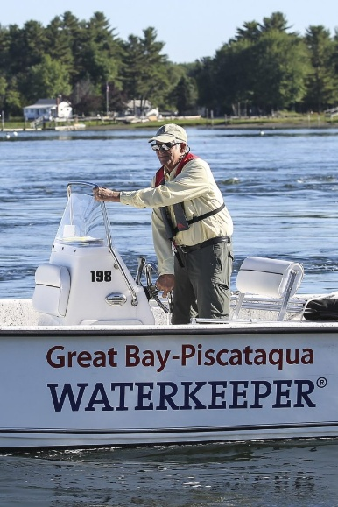

- Welcome to new members;

- Discussion regarding the Great Bay Changemaker Program with NH Fish & Game;

- Status of Knights Hill Parking / Trail Project;

- Review of Town-Wide Conservation Property Map;

- Website Update;

- Continuation of signage project – Knights Hill, ____________? ____________?

- Trickey’s Cove Trail / Access? Property boundary survey / confirmation?

- New Project initiatives;

- Review and Approval of 4.9.26 DRAFT Minutes;

- Other Business

- Adjournment.

